**Experiment 6**

**PART A**

|  |  |
| --- | --- |
| Roll. No. : A016, A018, A022 | Name: Varun, Simran, Kartik |
| Sem/Year : Sem-07/4th year | Batch: 1 |
| Date of Experiment : | Date of Submission: |
| Grade -- |  |

**A.1 Aim**

*To design scenarios and create personas for a given problem. (an application /website)*

**A.2 Prerequisite**

An understanding of design thinking concepts.

**A.3 Outcome**

After experimentation, students will be able:

* To understand and design the different scenarios within the problem to be solved.
* To create personas for the problem to be solved.

**A.4 Theory**

**Persona:**

A **persona** is a description of a target user for a product or service. A persona summarizes the target user’s background, goals, and needs related to the product. The persona helps you better understand your target users, so you can design a solution to meet their expectations.

A persona is based on user research data collected from **multiple** users through observations, interviews, surveys, etc. However, the persona is presented as a description of an individual person, even though the persona actually represents a group of users with similar characteristics.

The reason for presenting the user data as an individual person is because it is easier to empathize with a description of a specific person, rather than a set of statistics summarizing an entire group.

It is important that a persona is **fictional** (not an actual individual) **yet realistic** (based on real data from actual users). Since one purpose of a persona is to develop empathy for the target users, a persona should NOT be humorous or demeaning.

There are different formats for personas, but personas are usually condensed to one-page in length and often contain information such as:

* **Profile** (background information about user):
  + **Photo** (fictional - use stock photo)
  + **Name** (fictional - first name is sufficient)
  + **Type of User** (descriptive label or category)
  + **Relevant Demographic Information** that might affect how product is used or designed (might include: age, gender, occupation/role, etc.)
  + **Other Relevant Background Information** that might affect how product is used or designed (might include: description of physical, social, and technological environment in which product will be used; user’s proficiency with technology; special knowledge or skills; personality traits; etc.)
* **Goals and Tasks** (what goals or purpose does user want to achieve when using the product, and what tasks does user need to complete with the product to meet these goals)
* **Anxieties and Motivations** (what influences user’s behaviors and decisions related to adopting a possible new solution to meet the goals and perform the tasks)
* **Frustrations and Concerns** (what pain points does user experience with the current situation or current solutions)
* **Needs and Expectations** (what are user’s expectations related to the functionality, usability, and user experience of possible new solution)

A product or service might have many different types of users with different backgrounds, goals, and needs. Therefore, different personas could be created to model these different types of users. However, it might not be possible (or desirable) to design a solution that tries to meet the needs of every possible type of user. Often this results in a solution that doesn’t actually satisfy anyone. Instead, it is recommended to identify the **primary type of user** that will be your main target for designing your solution.

**Scenario:**

A persona is typically combined with one or more scenarios. A **scenario** is a brief story that describes how and why the persona would use the product to complete a specific task in a specific context. Different scenarios could be written for different tasks or different contexts.

The purpose of a scenario is to help the design team visualize how a target user would interact with the product in real-life. This can help with determining the functions and features of the product for design requirements, as well as with developing tasks for usability testing.

Refer Fig.1.for a pictorial description of personas, scenarios and goals.

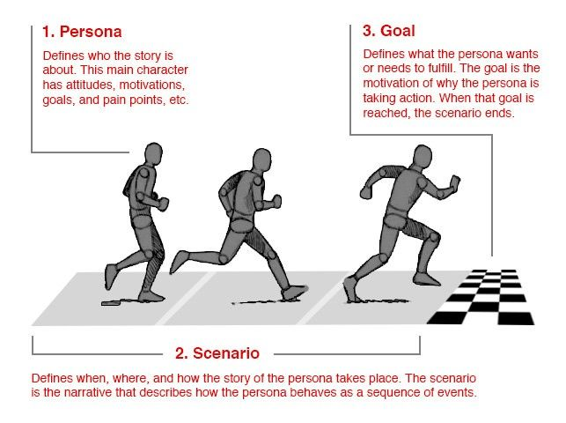

Fig 1. Persona, Scenario and Goals.

**A.5 Tasks to perform**

* 1. Visit the following link for understanding creation of persona from user research result

<https://www.interaction-design.org/literature/article/creating-personas-from-user-research-results>

Personas are deliverables in design thinking’s Define phase. As they’re extremely helpful in ideation, they should feature early in design processes. To create them, you:

* 1. Collect extensive data on target users.
  2. Determine the qualities of and differences between users.
  3. Develop a hypothesis from the research, determining the qualities of and differences between users.
  4. Ensure stakeholders agree on the hypothesis about the users.
  5. Determine a number of personas – more than one per project, but focus especially on one at a time.
  6. Name and describe each persona in 1-2 pages, including:
     + A picture.
     + User’s values, interests, education, lifestyle, needs, attitudes, desires, limitations, goals and behavior patterns.
     + Extra details about the persona (e.g., interests) – anything to make him/her more real and relevant and help build empathy. A written story is better than bullet points.
  7. Describe several situations/scenarios prompting the persona to use your product – put him/her in contexts with problems to overcome.
  8. Include everyone involved in the project so they’ll accept the persona or advise revisions.
  9. Send them the persona to use in their work.
  10. Ensure everyone develops scenarios – these should expose the persona optimally to potential use cases.
  11. Make continuous adjustments – revisit the persona; add new features; add required new personas; discard outdated personas.

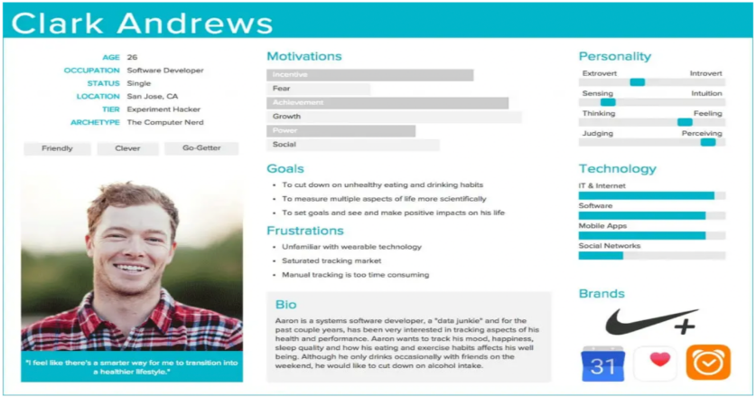

**(PART - B)**

(TO BE COMPLETED BY STUDENTS)

(Students must submit the soft copy as per following segments within two hours of the practical)

|  |  |
| --- | --- |
| **Roll. No. : A016, A018, A022** | **Name: Varun, Simran, Kartik** |
| **Sem/Year : Sem-07/4th year** | **Batch: 1** |
| **Date of Experiment : 14-10-2022** | **Date of Submission:17-10-2022** |
| **Grade --** |  |

**B.1: Task assigned:**

1. Create different personas as explained in Part A for your project using any tool like Figma, Xtensio, Lucidchart

**Persona 1:**

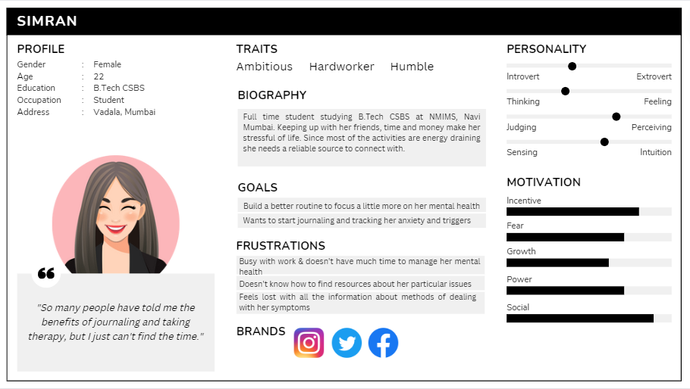

**Persona 2:**

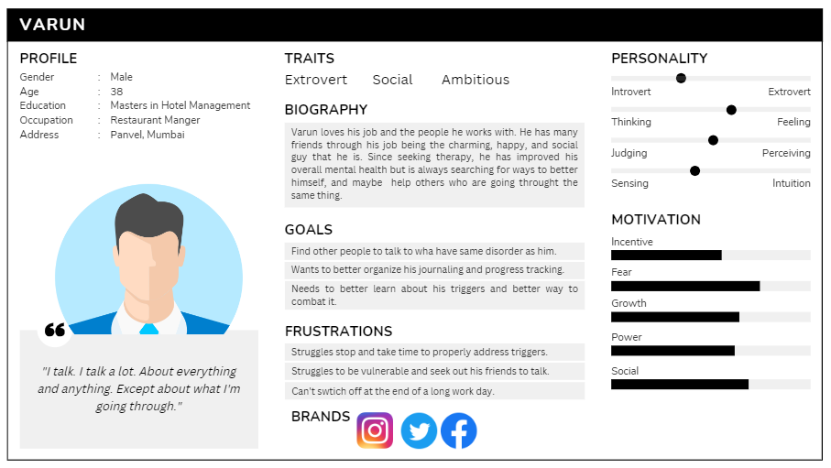

**Persona 3:**

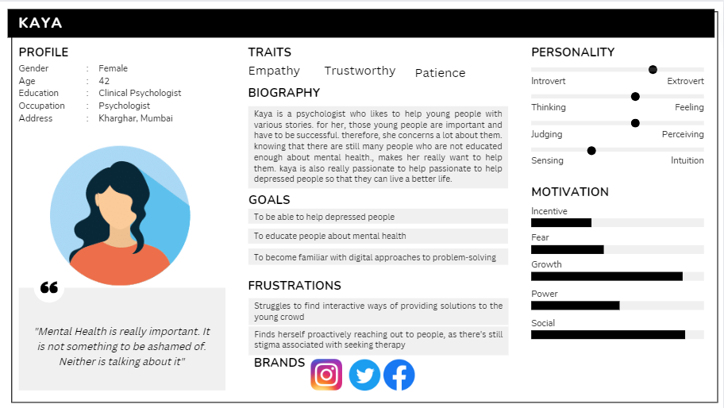

**Persona 4:**

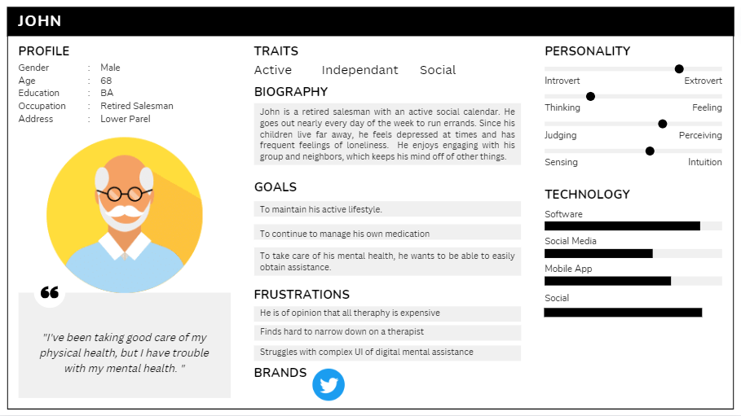

1. Describe several situations/scenarios prompting the persona to use your product – put him/her in contexts with problems to overcome. Ensure everyone develops scenarios – these should expose the persona optimally to potential use cases.

John is a retired salesperson who enjoys doing errands on occasion even in his retirement. He neglects his mental health because of all this activity, and he also forgets to take his medications on time. He discovered that many therapists were pricey, and that both internet apps and mental health services were expensive and challenging to use.

Simran, a college student, wants to start a new routine that prioritizes her mental health and start a blog about her life experiences. But because of her busy schedule, she is unable to take in other aspects of life. The variety of information and mental apps is another factor contributing to her inability to choose the best course of action for her goals and obstacles.

Restaurant manager Varun has trouble keeping a journal and managing his triggers. He wants others who have similar difficulties to him because he feels vulnerable discussing them with friends and family. He would also love to support them as they develop and solve their issues.

Kaya is a psychologist who likes to assist the more youthful era managing intellectual fitness troubles and desires to come up with interactive approaches to assist them address those troubles. She desires to train human beings approximately significance of getting an excellent intellectual fitness and familiarize every person which include her with the virtual manner of fixing this problem.

**B.2 Observations and Learnings:**

1. Pain Points: After analyzing the different scenarios where the identified personas are involved, list out the pain points (What irritates the person about the Product / service? /Fears/obstacles)
2. Current apps are hard to navigate and use.
3. Many modern therapists are expensive.
4. Apps do not have a community where people can express their concerns and help each other.
5. Gain Points: What are the current support the person has that makes him happy about the product/service? (What are the expectations from possible solution/goals/wishes)
6. Finding a therapist becomes easy and at a reasonable price.
7. Having a community helps the user to ask for help freely and help others is need.
8. Providing a simple, minimalistic UI helps in better navigation.

**B.3: Conclusion:**

(Students must write the conclusion as per the attainment of individual outcome listed above and learning/observation noted in section B.2)